Loguru cheat sheet

Installation
# Using pip
pip install loguru

# Using uv (Recommended for modern workflows)
uv add loguru

2. The Basics: "Hello World"
Unlike the standard library, you don't need to create a logger instance. You just import and go.
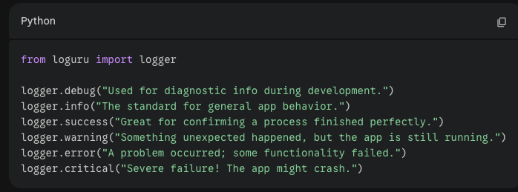

3. Sinks (Where logs go)
By default, Loguru sends everything to the console (stderr). You use .add() to send logs to files, emails, or other destinations.
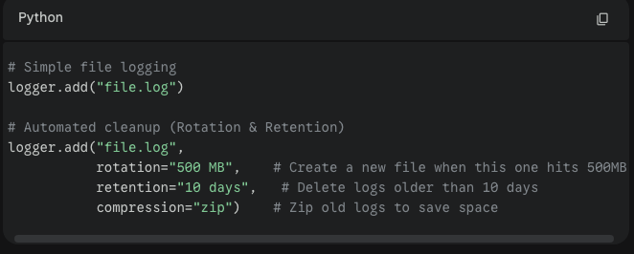

4. Formatting and Filtering
You can customize exactly how your logs look and which logs get saved.
Custom Format:
logger.add("special.log", format="{time:YYYY-MM-DD} | {level} | {message}", level="INFO")

Filtering: Only log specific things to specific files.
# Only save errors to this file
logger.add("errors.log", filter=lambda record: record["level"].name == "ERROR")

5. Advanced Concepts

The Exception Catch (The "Killer Feature")
Standard logging often loses the "traceback" (where the code actually broke). Loguru makes it easy to see exactly what happened.
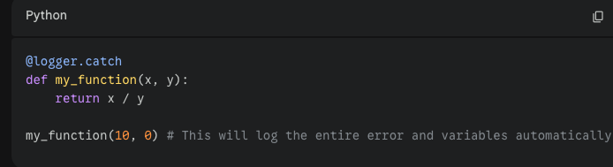

Structured Logging (JSON)
If you are sending logs to a server (like Datadog or ELK), use JSON format.
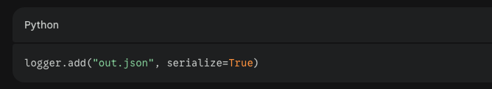

Interception (Replacing standard logging)
If you are using other libraries that use the old import logging, you can force them to use Loguru:
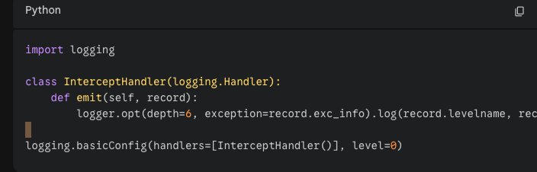
import logging

class InterceptHandler(logging.Handler):
def emit(self, record):
logger.opt(depth=6, exception=record.exc_info).log(record.levelname, record.getMessage())

logging.basicConfig(handlers=[InterceptHandler()], level=0)

Quick Cheat Sheet Summary Table
Goal | Code Snippet
Basic Log | logger.info("Message")
Save to File | logger.add("filename.log")
Format Logs | logger.add(sink, format="{time} {message}")
Delete Old Logs | logger.add("file.log", retention="1 week")
Catch Errors | @logger.catch above the function
Remove Sinks | logger.remove() (clears all previous .add configs)

Usage / syntax

The @logger.catch Decorator
This is the cleanest way to handle errors. You simply place it above your function. If the function crashes, Loguru automatically catches the error, logs the full traceback (the "stack trace"), and identifies exactly which variables caused the crash.

For functions
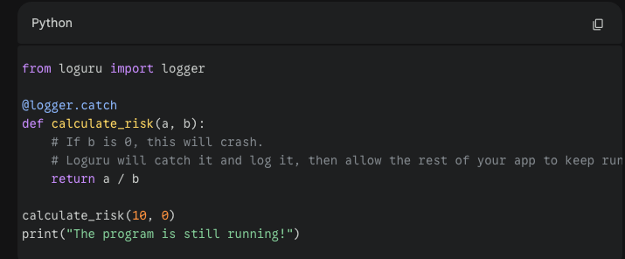

The Context Manager (For specific blocks)2
If you don't want to decorate a whole function, but just a few lines of "risky" code, you can use with logger.catch():
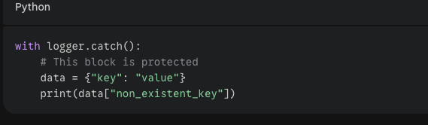

Try/Except VS logger.catch
You should still use a traditional try/except if you need to perform a specific action when an error occurs—for example, if you need to close a database connection or retry a network request.
- Use Loguru catch for: Monitoring, debugging, and preventing "silent" crashes.
- Use try/except for: Logic-based error recovery (e.g., "If file not found, create a new one").

Pro-Tip for your Automation Projects
Since you mentioned working on automation scripts, you can combine the "catch" feature with a log file. This way, if your script crashes while you aren't looking, you can open the log file and see exactly what the variable values were at the moment of the crash
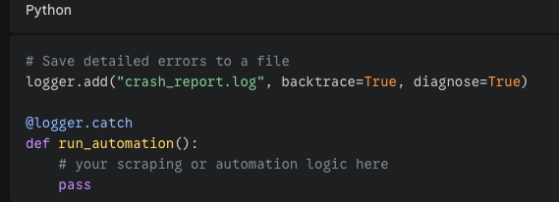
backtrace=True shows the path the code took, and diagnose=True reveals the values of your variables (like URLs or usernames) in the log so you don't have to guess what went wrong.

FYI:
Loguru only logs when there is an error or when you explicitly tell it to, OTHERWISE, WILL NOT
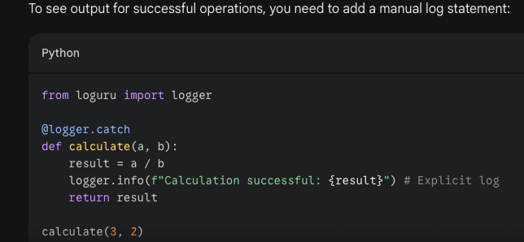
To be continued…

